

**Grant Application Form**

|  |  |  |  |
| --- | --- | --- | --- |
| Version | Date Adopted Policy | Minute Reference | Review Date |
| 1 | October 2016 | A & S 116-16 | October 2018 |
| 2 | June 2018 | F & E 380-18 | October 2020 |
| 3 | July 2019 | F & E 038-19 | October 2020 |
| 4 | May 2021 | F & E 053-21 | Oct/Nov 2021 |
| 5 | July 2022 | F & E 108-22 | October 2023 |

**GRANT AID APPLICATION FORM**

**FOR LOCAL PROJECTS**

|  |  |
| --- | --- |
|  | **Section 1 – About the Applicant** |
| 1 | Name of Applicant/Organisation |
| 2 | Applicant contact name, address, email and telephone*  ***\*Please note the whole application will be published in the public domain unless we receive express instructions to the contrary.*** |
| 3 | Aims & Objectives of Applicant / Organisation  Tell us a little about your organisation – what you do and why |
| 4 | What is the Nature of your Organisation?  ie are you a registered Charity, Social Enterprise or Community Interest Company?  If yes, please provide registration details: |
| 5 | Does Your Organisation Have:  A constitution: Yes / No  Accounts: Yes / No  Equal opportunities policy: Yes / No  Safeguarding or child protection policy**\*** Yes / No  Health and Safety policy Yes / No  Please include a copy of these documents where available.  If these documents are not supplied, please advise why these details are missing.  *\*If you are not able to provide a safeguarding or child protection policy, please advise how you will monitor and ensure the protection of children and vulnerable adults.* |
| 6 | Is your application for a reduced hire fee for any Town Council premises?  Yes No  If yes, what is the date of your event and have you booked the facility with the Town Council?  If No, please proceed to question 7. |
| 7 | Have you previously applied to SWTC for grant funding?  Yes / No  If Yes, please give details of when and if the application was successful, the grant received and the purpose**. Reminder that funding is restricted to one application per organisation per financial year (1st April – 31st March)** |
|  | **Section 2 – The Project** |
| 8 | Project name:  Project aim:  Start Date:  End Date: |
| 9 | Please give details of the project activities and timeline |
| 10 | What particular need do you consider the project will meet? |
| 11 | How have you identified the need for this project? Please include your experience in this field and research and scoping that has been carried out with the intended target group |
| 12 | Please give a reasonably accurate figure for the number of people, within Saffron Walden Town Council’s area (the parish of Saffron Walden and Little Walden, see map attached for the area served by SWTC), the project will serve. If possible, please provide evidence of this within the Data Protection Act |
| 13 | Please give a brief outline of:   * How this project benefits the residents of Saffron Walden Town Council’s area * The change you wish to see as a result of your project or activity for the residents of the Saffron Walden parish * How your project will be measured |
| 14 | Where will any equipment be kept and how will it be insured? |
| 15 | Address where main activities will take place |
| 16 | How will you ensure that the project will be all-inclusive? |
|  | **Section 3 – Funding Requirement** |
| 17 | What is the total cost of the project? Please attach a budget breakdown for this cost |
| 18 | Amount requested from Saffron Walden Town Council and for what purposes (please be as specific as possible) (please note grants are ordinarily restricted to £500 per application) |
| 19 | Have you applied for funding from other sources for **this project**?  Yes No  If yes, please indicate how much and who from |
| 20 | Have you applied for funding from other sources for **any other project** which may relate to this funding request? If so, please give details of when, and if the application was successful, please give details of the grant received. |
| 21 | How will you ensure that SWTC support of this project is promoted? |

|  |  |
| --- | --- |
|  | **Section 4 – Contact Details** |
| 22 | Contact details for this application  (this must be someone who has full knowledge of the application and can answer questions about it). Please note that these details will be made known in a public forum unless you specifically advise that details should be with-held  Name  Tel No  Email address  Date of application |
| 23 | Bank/Building Society Details  Grants will ordinarily be made by cheque payment.  Name to appear on cheque payment:  If this is not the name of the group applying, please provide an explanation for variance. |
| 24 | Declaration – **must be signed by at least 2 persons**  We confirm that the information given in this application is correct. We are authorised to make this application on behalf of:  Name of Organisation:  Signed: (1st person)  Name:  Position in Organisation:  Signed: (2nd person)  Name:  Position in Organisation: |

***Please note that this whole document will be published in the public domain unless we receive express instructions to the contrary.***

**Map showing the parish of Saffron Walden.**

**The Town Council serves all the area shown in white**

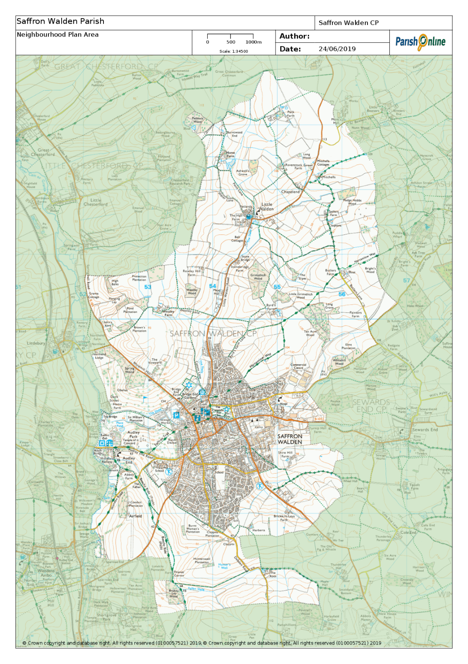

|  |  |
| --- | --- |
|  | **For Internal Office use only:**  **Information to Committee**  **Details of any previous grants awarded to this Organisation**  **(Provide details for grants in past five years)**  **Additional Information:**  **Recommended Source of Funding:**  **(As recommended by SWTC Officer)**  Youth Partnership  Current balance in budget ……………  (to Assets & Services Committee)  Small Grants Scheme  Current balance in budget ……………  (to Finance & Establishment Committee)  Free of Charge Hire  Current balance in budget ……………  (to Finance & Establishment Committee)  **To be completed for questions 6 & 7:**  Commercial hire cost:  Resourcing cost to Town Council (any additional cost):  Potential Net loss / profit to SWTC: |