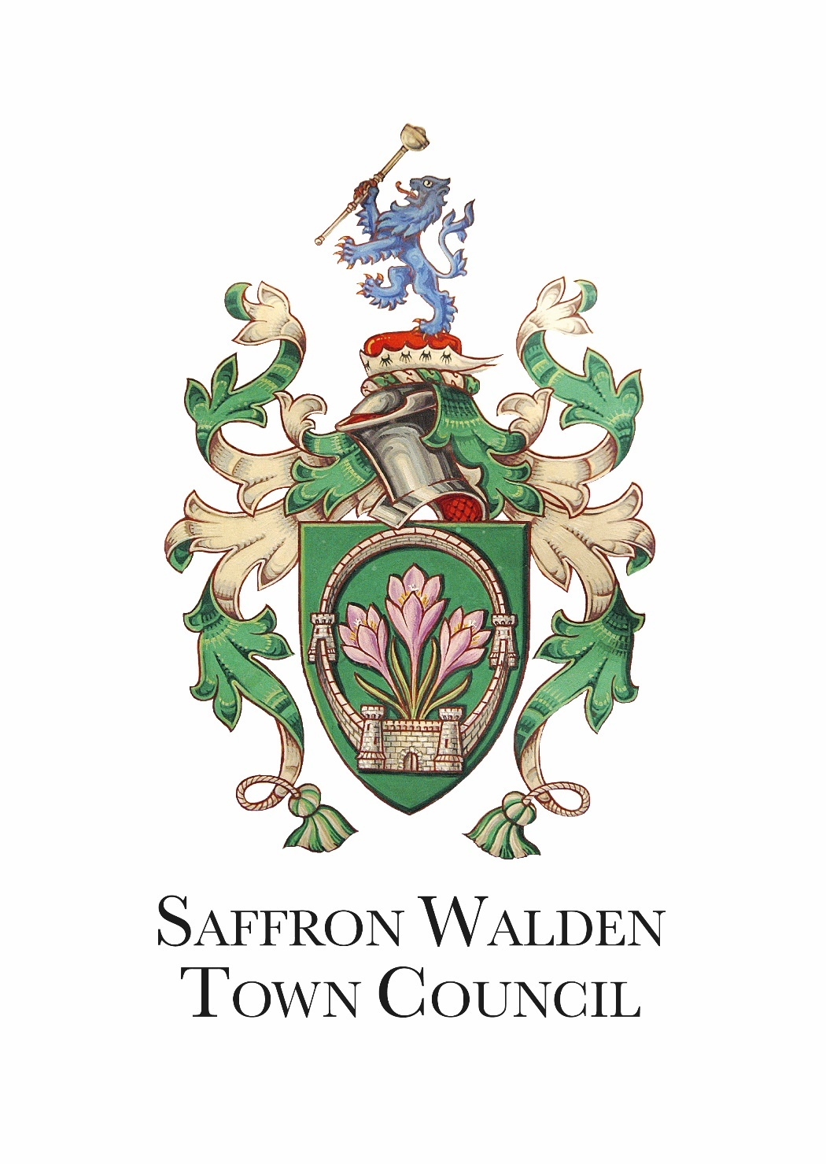

Community Engagement Policy

Version | Adopted Policy Date | Minute Reference | Review Date
1

Saffron Walden Town Council is very active in positive community engagement and is committed to reaching a wide audience, from all ages and backgrounds. Whilst SWTC cannot force any individual or group to become involved or participate in Council activities, SWTC can and shall promote engagement to encourage public to do so.

SWTC’s mission statement is to help represent the needs of the community. SWTC will engage with the public by using a range of communication methods to gather opinions, giving residents a voice to involve them in decision making for the Town.

Notably all interactions with the public must take a customer service approach.

SWTC Community Consists of, but not limited to:

- All Saffron Walden residents
- All users of SWTC services and facilities
- Teachers, students and parents of local schools in Saffron Walden
- Local businesses in Saffron Walden
- All those who work or own businesses within Saffron Walden
- All voluntary organisations, clubs and societies in or representing Saffron Walden
- Faith groups
- Care home residents, employees and visitors
- All relevant local authorities, services, interested bodies and neighbouring councils - ensuring strong working relationships are maintained
- Those who do not belong to any of these groups but have opinions related to Saffron Walden (perhaps previously lived in the area, live nearby or a visitor)

Communication

Communication is a key principle of community engagement; getting it right can lead to collaborative, interested and inclusive participation. Communication must be clear, concise and easy to understand. Alinksy S (1989, p81) notes “Communication with others takes place when they understand what you’re trying to get across to them. If they don’t understand then you are not communicating…..”
To comply with the Equality Act 2010, Council must consider the style, language and presentation of any consultation material. Communication should be individualised to the target audience, noting the need to provide literature in alternative languages if requested.
SWTC will actively seek to maintain and provide transparent communication to the community by carrying out the following:

- Publishing regular press releases and adverts to the local newspapers
- Up to date and relevant social media posts (SWTC/TIC)
- Up to date and relevant news article via the websites (SWTC/TIC)
- Council meeting agendas will be listed on the SWTC website and the Town Hall notice board
- Posters and leaflets promoting events and activities will be circulated in the community
- Email community contacts to share details of upcoming events and opportunities

SWTC is always open to receiving both positive or negative feedback, this is in line with our Complaints, Compliments and Comments Policy.

Engagement

When SWTC is seeking views on a specific project or idea and consults with the community the above communication channels will be used to promote engagement.

All consultations will be publicised as widely as possible with defined start and end dates with a clear explanation as to why the topic is being consulted on and how the results will be used in SWTC’s decision making process. Engagement methods may also include:

- Consultation days, allowing discussions to take place directly with the public
- Availability for responses to be made online and offline by using paper copies of a survey or encouraging feedback over the phone or directly to officers or members face to face.

Importantly, consultation activities will be:

- Interesting and Informative
- Engaging
- Of value and worth
- Easily understood
- Be clear in what they are trying to achieve
- Communicated in an appropriate manner to the target audience
- In the right place, at the right time

Reaching Target Audiences
Where necessary and appropriate to do so, consultations may be targeted, and we will reach these audiences through a range of forums including:

• Schools
• Youth Clubs / Councils
• Sure-Start Centres
• Residents’ Associations
• Disability Groups
• Uniform Groups (eg Brownies, Scouts)
• Sports Groups / Clubs
• Age UK
• Community Volunteer Services (CVS)
• Mums and Tots Clubs
• Faith based groups
• Racial, ethnic and cultural groups

Council Meetings

The Community is welcome to attend all public Council meetings and participate within the public speaking section.

The Annual Meeting of electors will continue to be well advertised encouraging public attendance and participation.

Contacting SWTC

The community is welcome to contact SWTC by:

- Visiting or telephoning the SWTC Office or Tourist Information Centre
- Submitting an enquiry via the SWTC website
- Emailing SWTC members or officers

Other methods (i.e., via social media) are available and welcome.

The Equality Act contains details of protected characteristics which are: age • disability • gender reassignment • marriage and civil partnership • pregnancy and maternity • race • religion or belief • sex • sexual orientation

